Guide - Release Change in ServiceNow

Objective

Release Change Process

Release Change Process for ENHR in ServiceNow
The Release Change process for ENHRs is the same used for Incidents, Requests, and PRBM tickets, with some exceptions.
- It must be used to record all global approvals linked to the ENHR, replacing email approvals. Note:
  - The ENHR Requester is not a mandatory Approver in the Release Change and will continue to provide a milestone approval in the ENHR itself, not in the Release Change, unless the ENHR is being implemented in multiple phases and the Requester is one of the Global Testers.
- If the ENHR is NOT Global and the Requester is the only approval required in the ENHR, the ENHR's IT Manager must be added to the Release Change as an Approver to complete the cycle in the ServiceNow Release Change before the scheduled Release, so that it is approved by CAB.
- If an ENHR is being implemented in multiple phases, a decision must be made between creating CHILD ENHRs or using multiple Release Changes for the phased implementation in production.

Create a Release Change:
- A Release Change can be created at any time when the ENHR Status is "Build" or "Test".
- Multiple Release Changes can be created for a phased implementation with the appropriate Release Schedule.
- In an Incident, Request, or Problem ticket, right-click on the GREY bar and select: "Create Release Change".
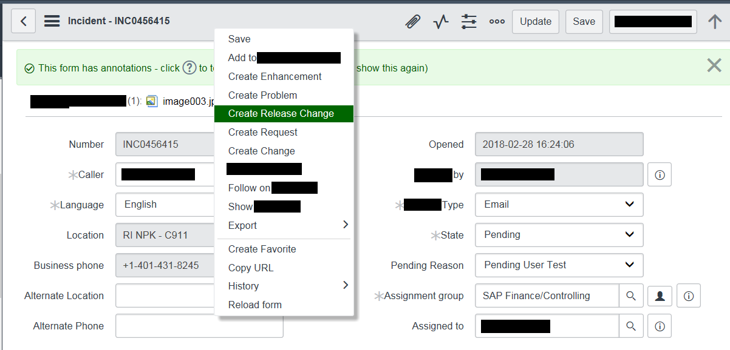
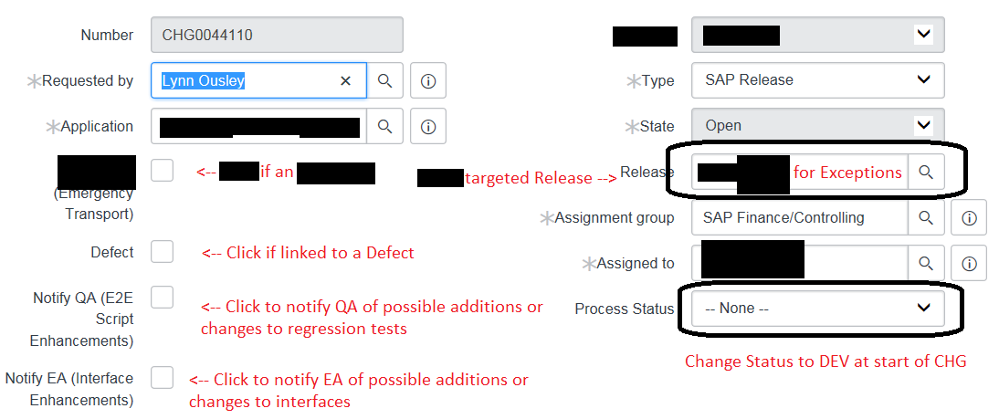
- Release: Select the target Release month (dropdown menu).
- Leave blank in case of Exception.
- "Assignment Group": can be determined from the "Assigned to" field once it is filled in.
- "Assigned To": Functional Analyst or IT Manager (verify).
- "Process Status": Change to "DEV Start" (dropdown menu).
- SAVE

Multiple Phases
- If the ENHR has multiple phases, the "Short Description" and the "Long Description" in the Release Change can/should be changed to something more relevant to what will be deployed in production. This text will be displayed to the Business when they receive the Release Change approval request.
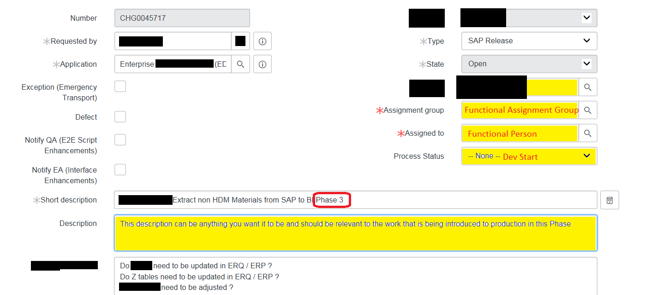
- If an ENHR is being implemented in multiple phases and you choose not to create CHILD ENHRs, it is possible to create a dedicated Release Change for each deployment phase in order to record the corresponding approvals.
- Each Release Change must have a target Release date defined.
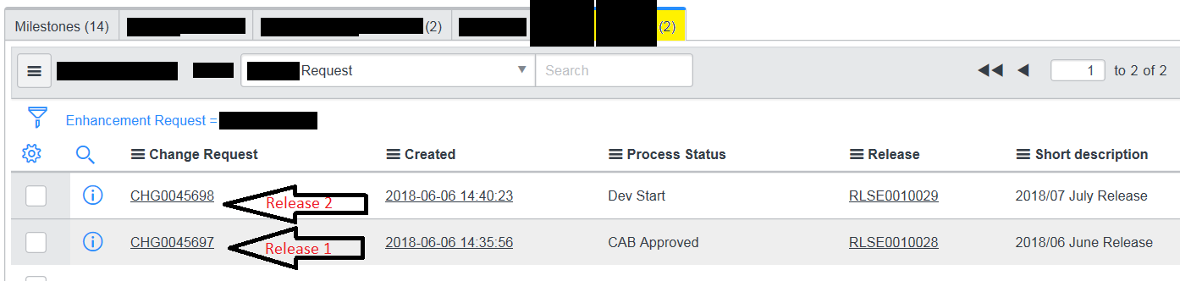

Process steps after creating a Release Change
Create Change Tasks:
- In the "Change Tasks" tab of the Release Change, add tasks for development work that must be completed by others in the appropriate assignment group. Be as descriptive as possible.
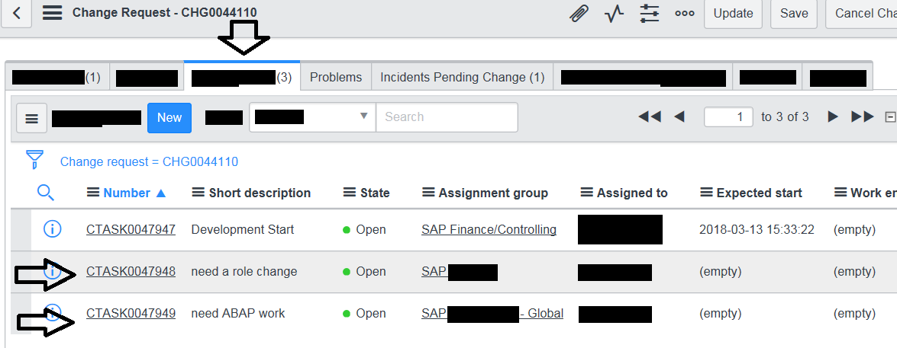

Assignment Groups
- SAP ABAP — For development work.
Closing a Task
- Child tasks must be closed by the assignee in the assignment group before the functional lead engages the Business to start testing. If there is more work to be done, open a new task.
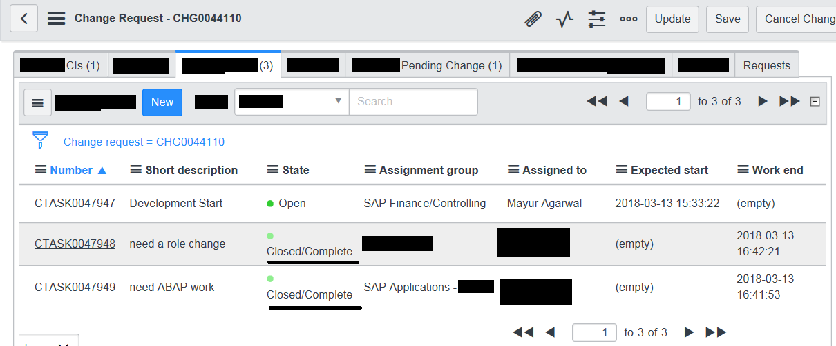
Change Request Approvals
- Before recording Business approvals in the Release Change, all Change Tasks must be closed.
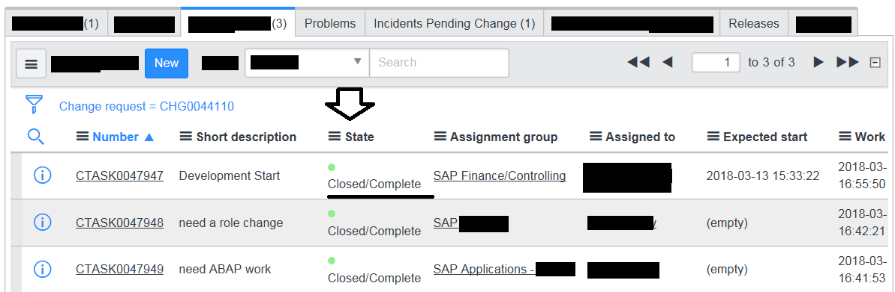
- The status will automatically advance to "Dev Completed" once all Tasks are closed/completed.
- DO NOT advance the status manually, as this will break the Workflow.
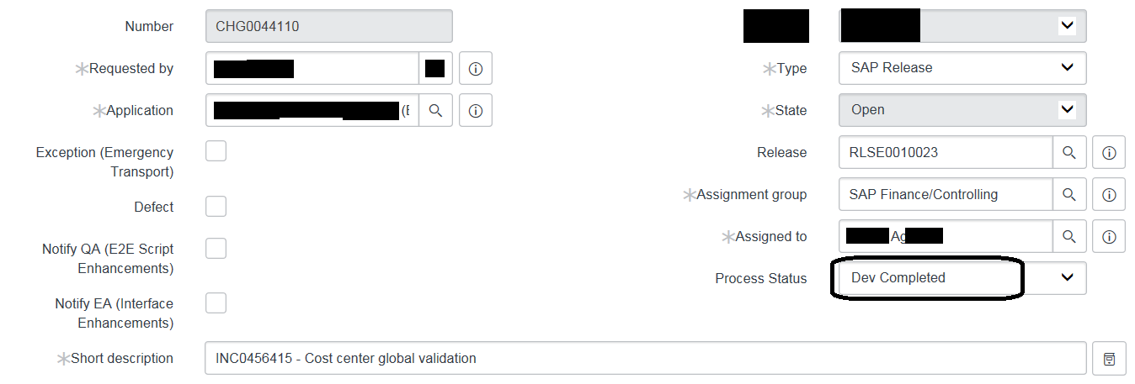
Add Approvers:
- In the "Approvers" tab, add one or more approvers who need to test and approve the changes.
- If there is only one tester, add the IT Manager as an approver to complete the cycle in the Release Change.
Note: The ENHR Requester must provide approval in the ENHR itself, not in the Release Change.
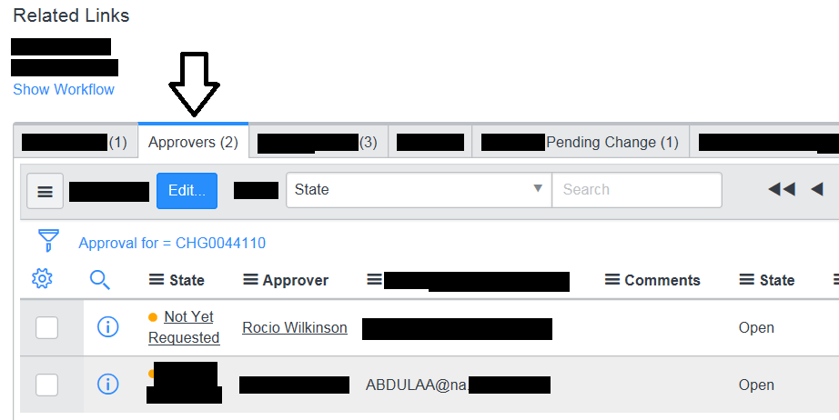
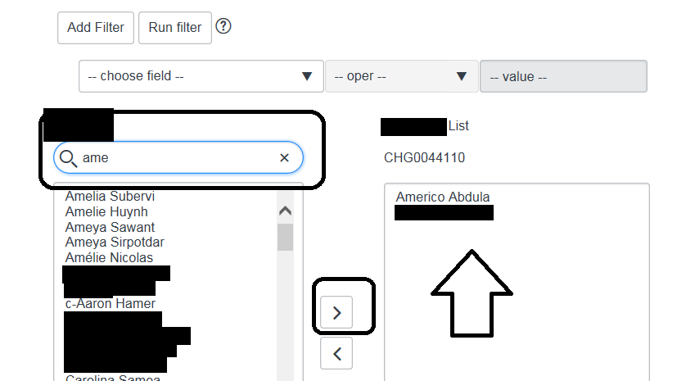
- After adding approvers, advance the status to "UAT Request".
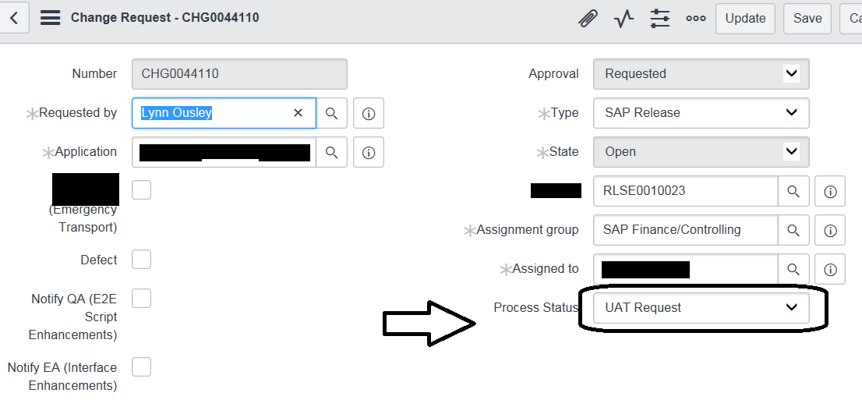
- The state will automatically advance to "Requested" once the "Process Status" is changed to "UAT Request".
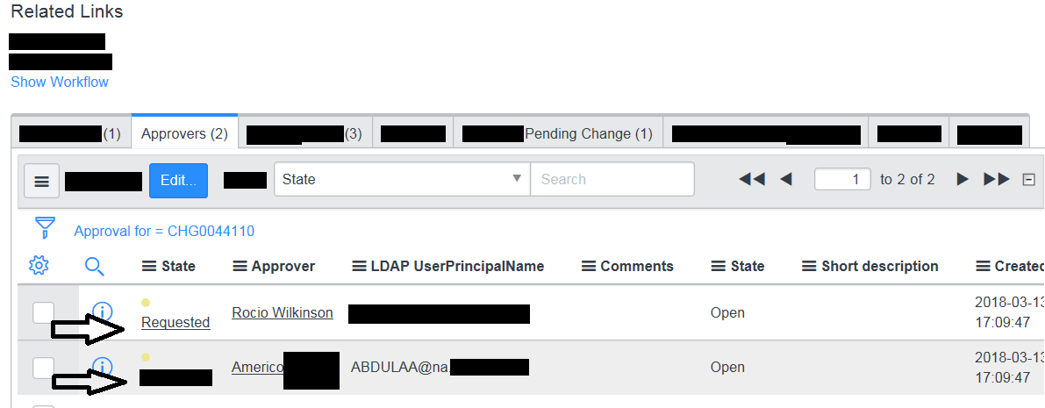
- A ServiceNow email will be sent to the Approver(s).
- If the Approver does not find the approval email in Outlook, it can be resent directly from the Release Change.
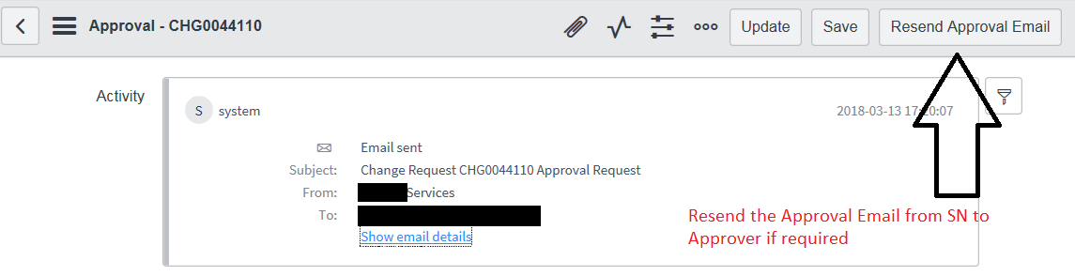
- The Approver(s) must click the corresponding link in the ServiceNow email to record their approval(s).
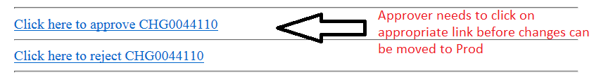
- After approval, the "Process Status" will automatically advance to "UAT Approved" and a ServiceNow email will be sent to the CAB team for approval (usually approved after Wednesday's CAB).
ATTENTION: DO NOT advance the status manually, as this will break the Workflow.
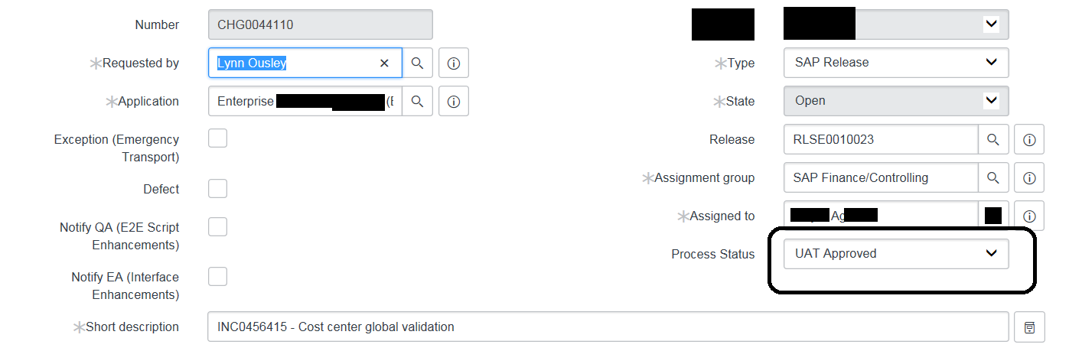
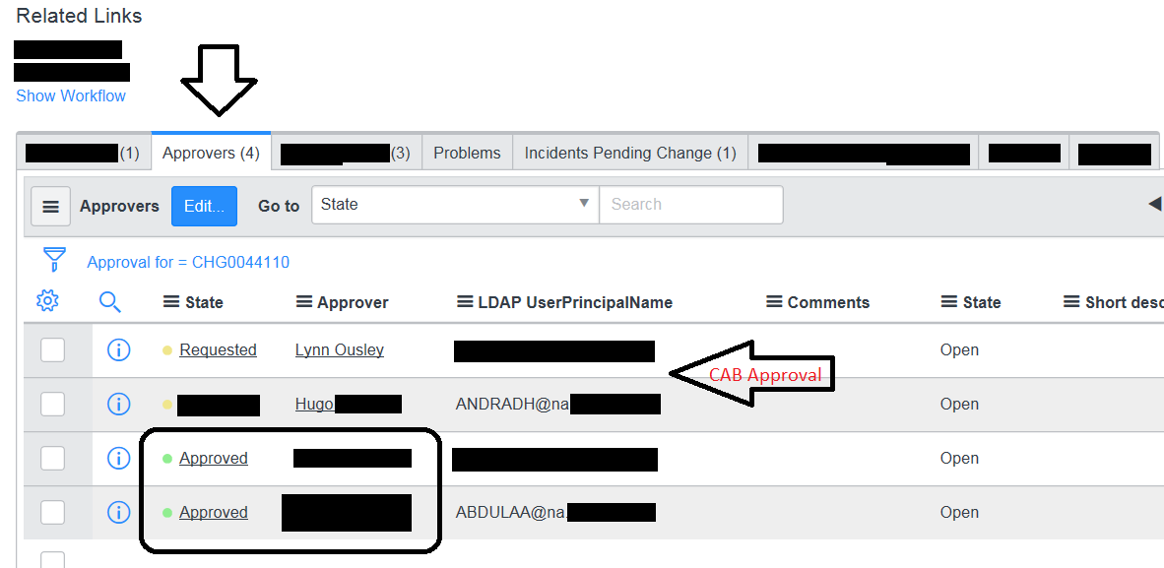
- CAB Approval
- After CAB approval, the state will automatically change to CLOSED/COMPLETE and the "Process Status" will move to "CAB Approved".
- DO NOT advance the status manually, as this will break the Workflow.
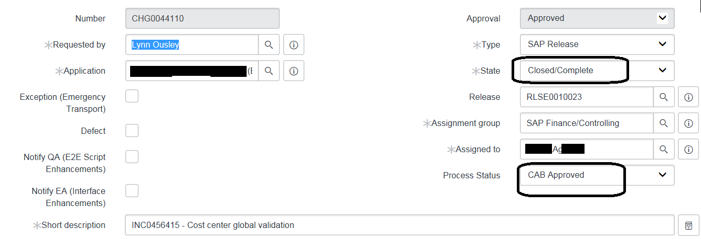
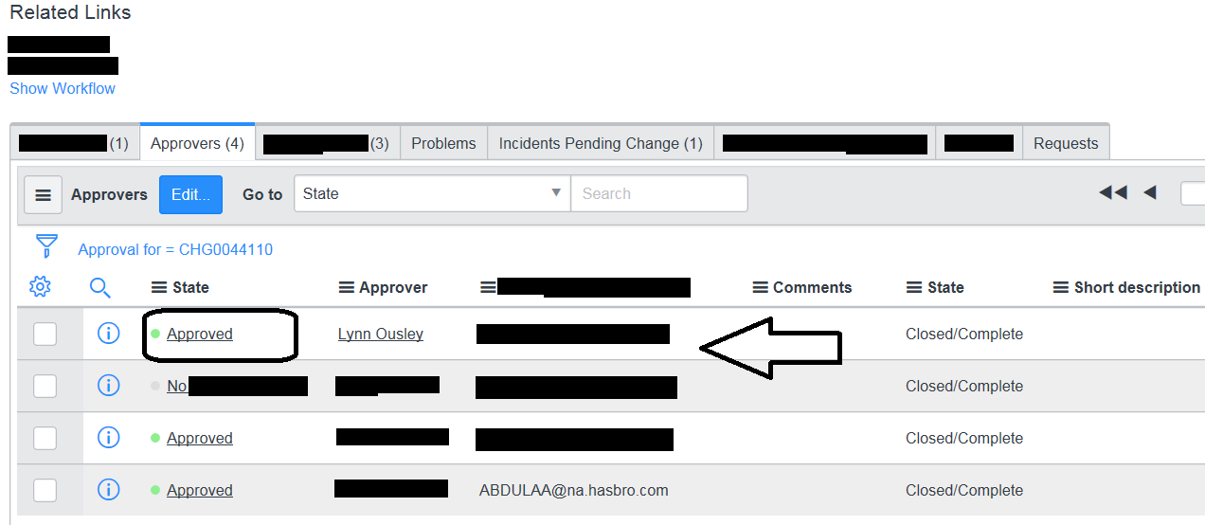

Related Links

Related links for Incidents (example):
- The "Related Records" tab links to the Release Change created for this Incident in ServiceNow.
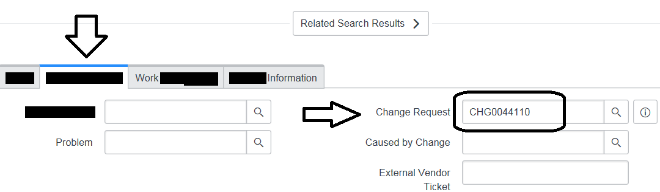
- The "Incident Pending Change" tab links to the INCIDENT used to create this Release Change.
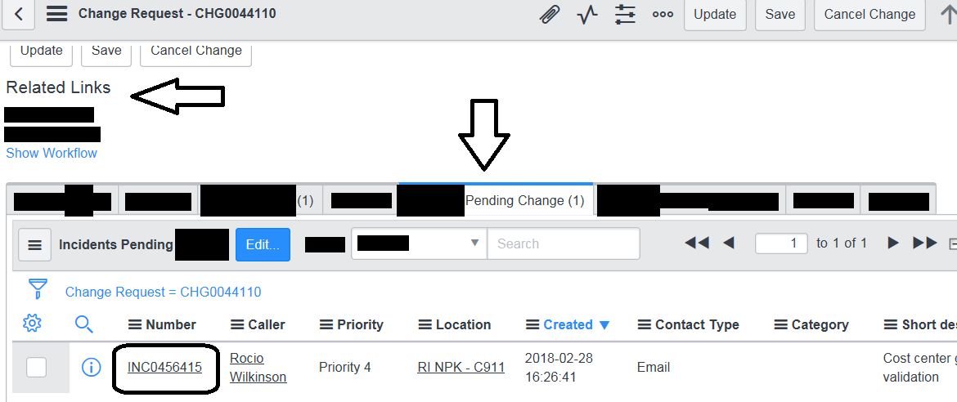

Related links for Requests (example):
- The "Change Request" field links to the Release Change created for this Request ticket in ServiceNow.
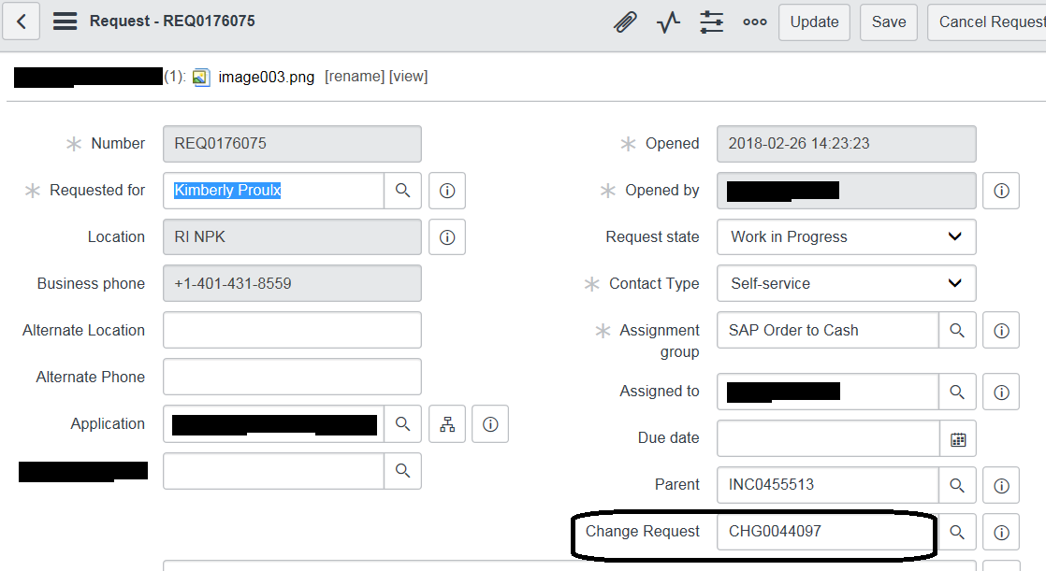
- The "Requests" tab returns to the Request used to create this Release Change.
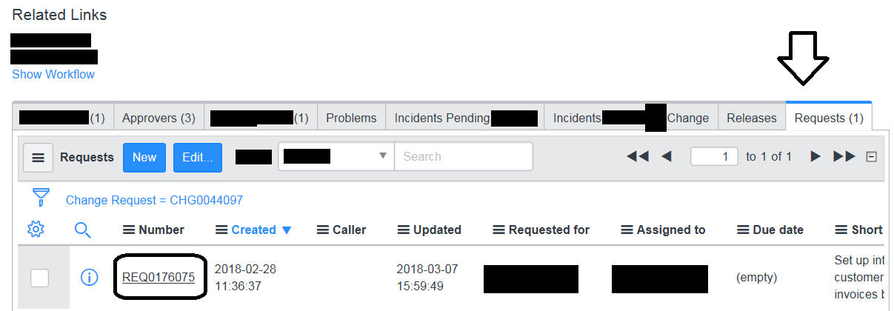

Related links for PRBM (example):
- The "Change Request" field links to the Release Change created for this Problem ticket in ServiceNow.
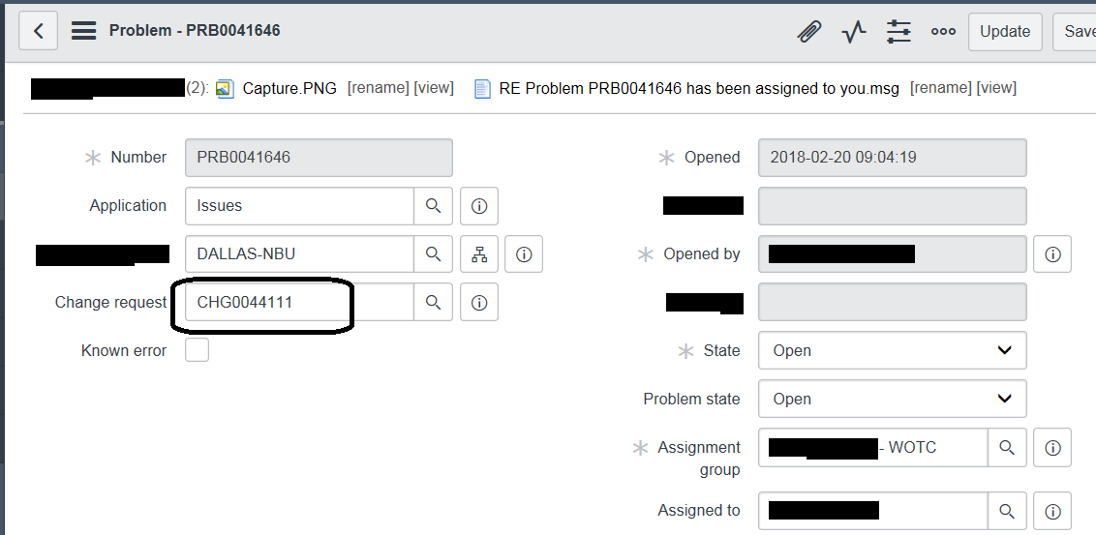
- The "Problems" tab returns to the PRBM used to create this Release Change.
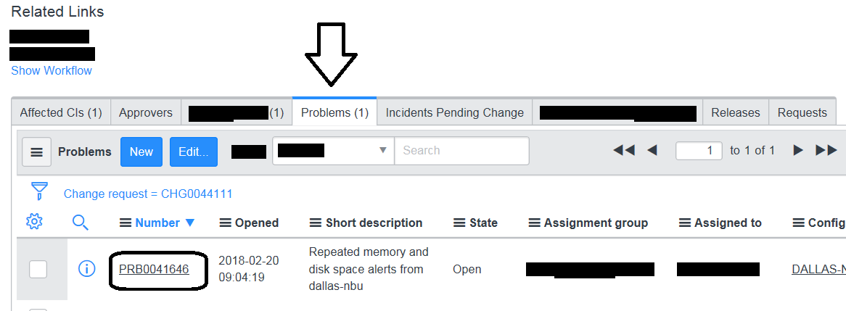

Related links for ENHR (example):

The "Change Request" field links to the Release Change created for this ENHR.
- The "Enhancement Request" tab returns to the ENHR used to create this Release Change.
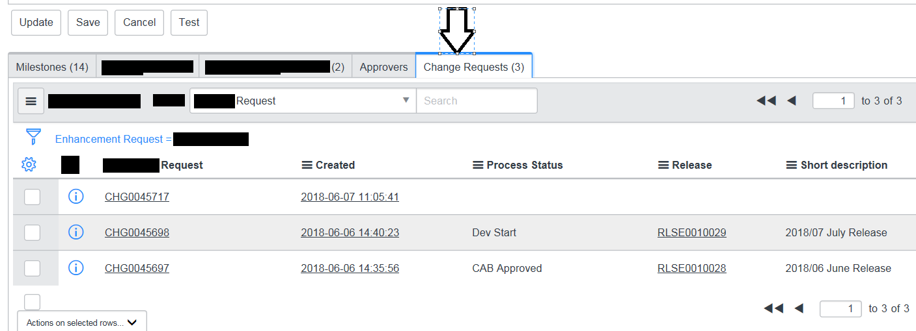
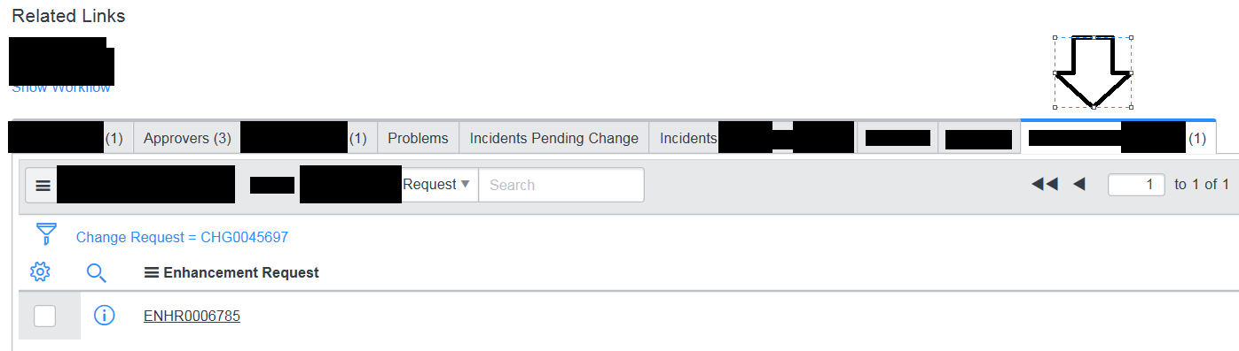

Version History
Author | Version | Date | Description
Lucas Souza | 1.0 | Jun/2026 | Translation to PT-BR

